NATIONAL UNIVERSITY OF
TECHNOLOGY


Computer Science Department
Advance Programming lab
LAB OEL # 02
Course Code: CS325
SUBMITTED TO

PROFESSOR ZOHAIB MEHMOOD
SUBMITTED BY:
Name: MIAN SHAKAR AFZAL
Registration No: F23605073

QUESTION NO # 01

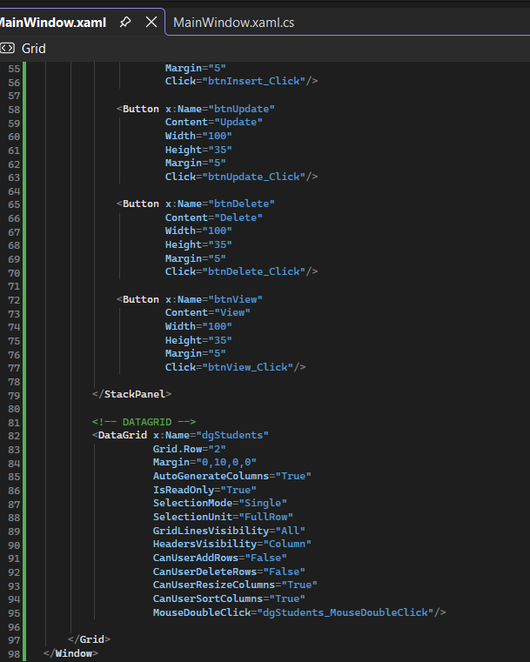
MainWindow.xaml.cs
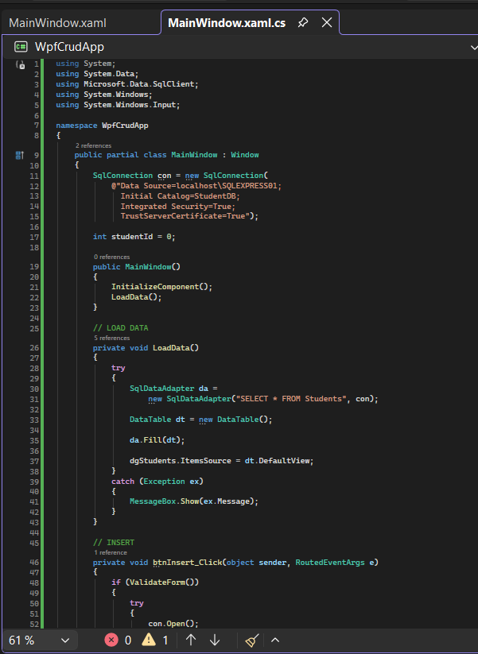

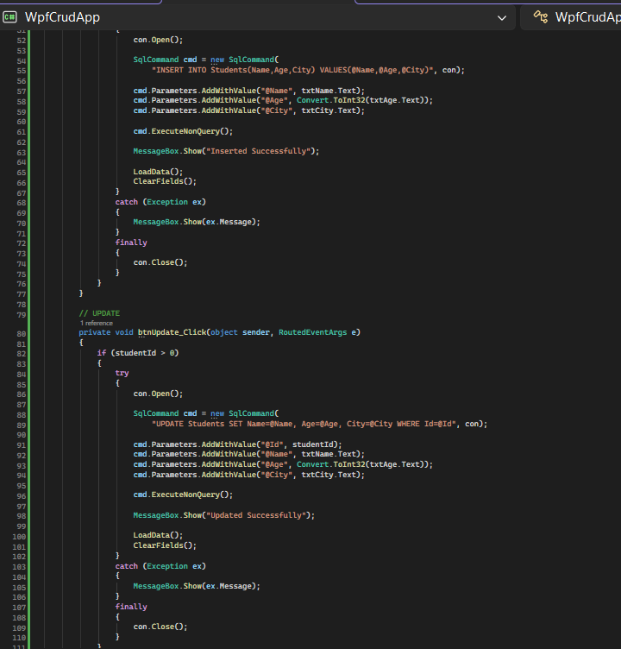
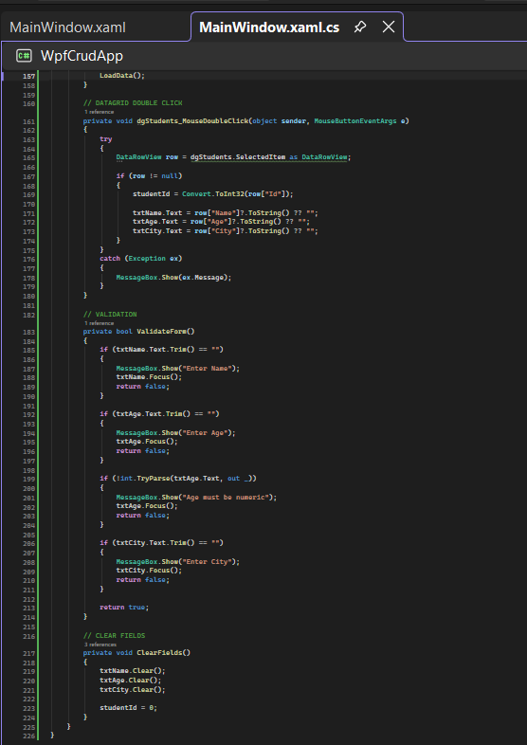
CRUD OPERATIONS
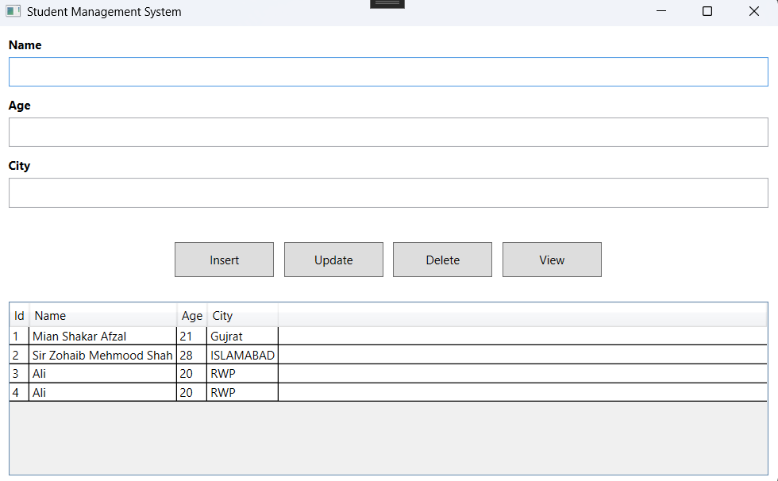
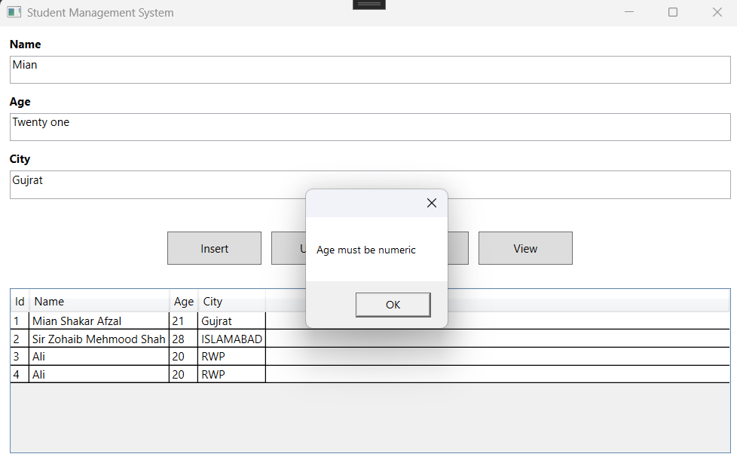
QUESTION # 02
✅ Steps to Connect WPF Application with SQL Server Using Connection String in C#
1. Create SQL Server Database
First, open SQL Server and create a database and table:
CREATE DATABASE StudentDB;
USE StudentDB;
CREATE TABLE Students
(
Id INT PRIMARY KEY IDENTITY(1,1),
Name NVARCHAR(100),
Age INT,
City NVARCHAR(100)
);
2. Create WPF Project in Visual Studio
Open Microsoft Visual Studio and:
- Click Create New Project
- Select WPF App (.NET)
- Name the project (e.g., WpfCrudApp)
- Click Create
3. Add SQL Server Namespace in C#
In MainWindow.xaml.cs add:
using System.Data;
using System.Data.SqlClient;
4. Create Connection String
Write SQL connection inside your class:
SqlConnection con = new SqlConnection(
@"Data Source=localhost\SQLEXPRESS01;
Initial Catalog=StudentDB;
Integrated Security=True");
Explanation:
- Data Source → SQL Server name
- Initial Catalog → Database name
- Integrated Security=True → Windows Authentication
5. Open Connection When Needed
Example:
con.Open();
Close after operation:
con.Close();
✅ Designing Single-Page WPF Form (UI Design)
6. Create UI with TextBoxes and DataGrid
In MainWindow.xaml:
Input Section (TextBoxes)
Used to enter data:
<TextBox x:Name="txtName"/>
<TextBox x:Name="txtAge"/>
<TextBox x:Name="txtCity"/>
7. Add Buttons for CRUD
<Button Content="Insert" Click="btnInsert_Click"/>
<Button Content="Update" Click="btnUpdate_Click"/>
<Button Content="Delete" Click="btnDelete_Click"/>
<Button Content="View" Click="btnView_Click"/>
8. Add DataGrid for Displaying Data
<DataGrid x:Name="dgStudents"
AutoGenerateColumns="True"
IsReadOnly="True"
SelectionMode="Single"
SelectionUnit="FullRow"/>
Purpose of DataGrid:
- Displays database records
- Allows row selection for update/delete
- Shows all data in table format

QUESTION # 3
